

Written by Sara Kwon
BEC Community Map: Leader’s Guide

Communal Evangelism Toolkit

BEC Community Map: Leader’s Guide
By Sara Kwon

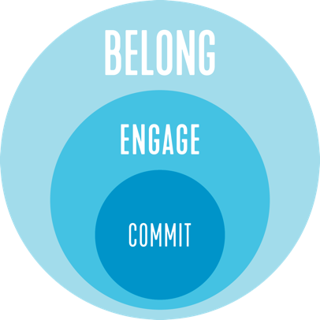
Goals
- Learn the BEC Community Map
- Identify and discuss your community’s strengths and opportunities for growth in evangelism.
- Discern your next steps and practice communal evangelism together.

Leader Preparation
- Look over the BEC Community Map Worksheet and fill in the map.
- Read through the outline below. Make notes of what you want to say or where you need additional prep.
- Read Chart 1 on the worksheet. Prayerfully identify communal strengths and changes beforehand so that you are ready if your group needs help.
- Print out a worksheet for each person.
- Decide how you will show the video and how you will fill in the BEC Community Map together.
- Pray for your community and your hopes for communal evangelism.

Quick Links
- BEC Community Map Worksheet
- BEC Community Map Video
- Becoming a Host Training

Training Agenda (1 Hour Total)
Time | Instructions | Leader Tips
0:00 | Introduction  (1 min) Read the introduction.  (2 min) Discuss in pairs: What has been your experience of evangelism?  (1 min) Ask for 2-3 people to share briefly in the large group.  (1 min) Pastoral word: We all have different experiences and feelings about evangelism. I invite you to bring that as we explore what we want evangelism to look like for our community. | Keep in mind that people are entering this conversation from different places. If some don’t like the word evangelism, use a different word to convey what outreach will entail for your community.
0:05 | BEC Community Map Video  Watch the video. | Make sure to cue the video.
0:10 | Discuss the video as a group.  - (2 min) How do you feel about doing evangelism together as a community?  - (4 min) Where have you seen belong, engage, or commit in your community? What stories from your own experience does this bring to mind? | Be ready to share a story or example of B, E, or C from your own experience.
0:16 | Fill in the map to discover your community’s strengths.  On a whiteboard or slide, draw a blank map and fill it in together as a community.  - (4 min) SPACES: First identify communal spaces and events that you host and write them on the map. Some spaces will overlap multiple categories. Write them as such.  - (4 min) FRIENDS: In a different color, write people’s names on the map. Encourage the group to think about people who do not identify as Christians or who are new to your community.  Optional follow-up question (if you want your group to look more closely at the people):  - What do we know about these friends and why they participate in these spaces? | Need: a whiteboard or PowerPoint with the blank map.  See the appendix if you need reminders of what Belong/Engage/Commit spaces entail.
0:24 | Observe & Interpret  (3 min) Individual time: Give people 3 minutes to reflect individually and answer the questions.  (3 min) Share in pairs: Give people 3 minutes to share their answers in pairs.  Group discussion: Invite the group to discuss the questions.  - (4 min) COMMUNAL STRENGTHS: Make sure to affirm and encourage the strengths y’all see in your community. Those are gifts!  - (4 min) COMMUNAL CHANGES: Make sure to look candidly and constructively at places needing change, while guarding against a spirit of criticism or shame.  *Optional:  1. Let’s pause for a second. What feelings does this bring up in you?  2. Let’s spend a moment listening to the Spirit – is there anything God is inviting us to pay attention to? | See Chart 1 to help you identify communal strengths or changes.  *During this exercise, your group might feel different emotions. Pay attention to how people are feeling. If necessary, use the optional questions to hold space for feelings and press into what the Spirit is bringing up.
0:38 | Next Steps  - (5 min) Decide: Decide on 1 area (B, E, or C) to focus on together and choose 1 change you need to make in this area.  - Look at your list of changes and the chart and choose 1 change you need to make as a community. We’ve found that focusing on is better than trying to do everything all at once.  - Several changes entail modifying a space and inviting people in.  - (12 min) Implement: Discuss how you will implement this change and do 1 step this week.  - Write down what you decided in step 1.  - Brainstorm what your community needs to do to make this change. Try to identify at least 2-3 next steps.  - When will you implement each step? What will you do this week?  - Who will take lead for each step? What is each person’s role (if any)?  - Schedule time to debrief and follow through on implementation at the next meeting.  - (3 min) Pray together for your community and the friends you wrote on the map. | Facilitation Idea:  If you have a big leadership team, you could break up into sub-groups. Put small group leaders together, large group team together, and so on. Then each sub-group can discuss amongst themselves the changes they want to make in their respective structures. Ask someone from each sub-group to take notes and to send a team reminder message after the meeting.  You can pray as a whole or in groups of 2-3.
0:58 | (2 min) Closing: Highlight the main points and next steps of your discussions.
1:00 | End

